1. Elevate your user access to root.

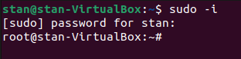

To elevate a user to root we can use sudo command, which allows us to execute commands with root privileges, In order to do that, we need to type sudo su, or sudo -i and enter user password
sudo -i →gives you a root prompts with a new shell environment as if root did a login, also does a cd to root’s home directory.
Sudo su → uses the normal su method of becoming root bud does not need a login.

2. Add a new user and set a password.

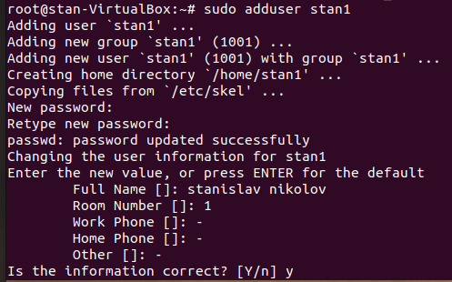

We need to type the command sudo adduser username, where “username” is the name you want to give, then the system will prompt us to enter and confirm a password for the user, the the system will prompt us for more info, once we complete this, the new account will be created and we can go log in in the new user.

3.Test if you can log in using that user.

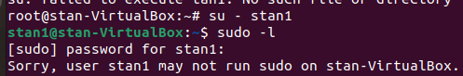

Because we are in root user, we need to enter su – username, where username is the name of the new account, then if we try to execute commands that we don’t have permission, it will prompt that the user can’t run that command.

4.Using grep command check if the user is created.
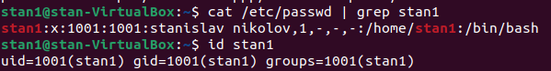

In order to use the grep command if a user Is created on Linux, we need to type “cat etc/passwd | grep user”, where the user is stan1, because the user exists, the system will display details. Including user id, group id, home directory, shell, and another info. Also we ca use “id user”, where user is the user that we want to check.

5.grep the UID of each user.

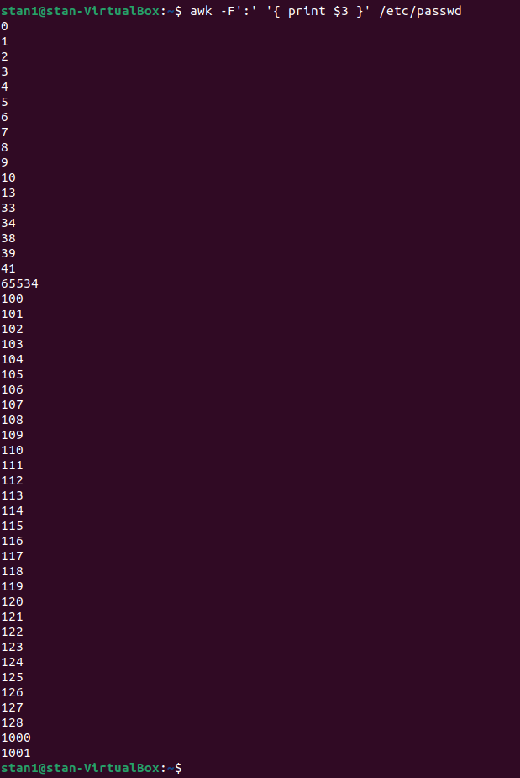

To grep the UID, which stands for user ID, we can cut use awk, this is a processing tool, that can perform various operations on text files, like filtering, sorting, extracting data and so on.
Then -F’:’ this option specifies the delimeter used in the input file, in this case the delimeter is a colon, which separates ‘/etc/passwd’ file.
Then ‘{ print $3 }’ this is and awk script that tells awk to print the third field, which is the user id
And ‘/etc/passwd/’ is the input file that contains the user account info.

6.Gind the GID of the created user.
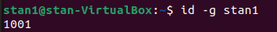

To find the GID, which stands for Group ID, we need to type id -g username. Were the username is the user we want to check. The id command displays the user id and group id, but in this case we are telling with -g, that we want to display the group id.

7.Change the password of the user and forc it to change the pass on his next login.
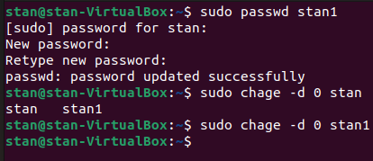

In order to change the password on the next login, we can use sudo passwd username, where username is the user’s account that we want to change the password, then we will be prompted for a new password for the user.
The change is successful, so the output is that the change is successfully done, and in order to force the user to change the password on their next login, we need to type “sudo chage d 0 username”, where the username is the name of the user that we want to force to change their password, also “chage“is used to confugure the password aging information such as number of days, between password password changes or the date of the last password change, and the “-d 0” is an option that specifies the date of the password change, if it’s 0, that means that the user will be forced to change it on the next login.

8.Add a new user and set an expiration date for it, with a five-day warning period.

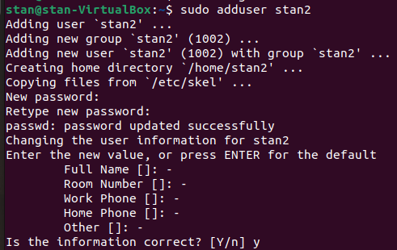

First we are creating a new user as the previous one, but here we are setting an expiration date with five-day warning period, so in order to do that, we need a command “sudo chage -E 2023-03-15 -W 5 username”, where the username is the user that we want to warn.

-W 5 is an option that sets the number of days before the password expires when the user will receive warning
E 2023-03-15 is setting the date when the user account will expire.

9.Create a new group.

With the command “sudo groupadd groupname”, where the groupname is the name if the group, we created a new group.

10.Assign the two new users to that group.

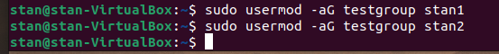

In order to assign one or more users we can use “sudo usermod -aG groupname username”, where groupname is the name of the group, and the username is the user, that we want to append to the group
-a is for append and -G is for group.

11.Lock one of the user accounts.

In order to lock the account we need to type the same command, but here the flag is -L for lock.

12.Change the shell of one user to tcsh.

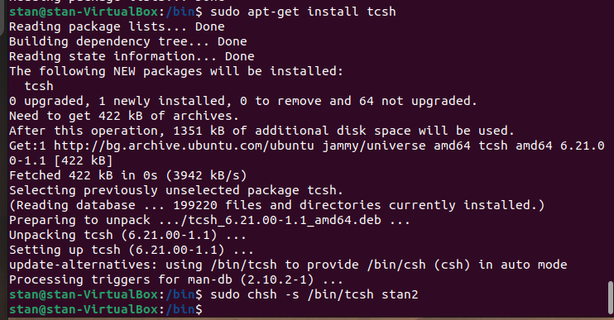
After installing the tcsh, we are changing the default shell of a user to tcsh(TENEX C Shell).

13.Make sure your home directory has “execute” access enabled for group and other.

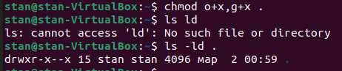

In order to grant the right to “execute”, we need to type “chmod o+x,g+x .”
chmod os changing the file mode
“o+x” this sets the execute permission for others(users who are not the owner or member of the group)
“,” this separetes the different sets of permissions that we want to set.
“g+x” sets the “execute” permission for the group.

“.” specifies the current directory as the target of chmod.

14.Change to your home directory, and create a directory called labs.



Here we are creating a directory named “labs”.

15.Create an empty file in labs directory
16.Change permissions of the file to rwx-rwx-rwx
17.List the file.What color is the file?

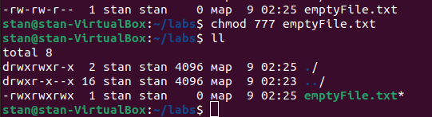

In order to change the permissions of file to `rwx-rwx-rwx`, we need to type “chmod 777 filename”, where filename is the name of the file,
and 777 specifies the permissions we want to set for the file, each digit represents a set of permissions: the first digit represents the permissions for the owner of the file, the second digit for the group of the file, and the third digit represents the permision for the others, the values for digits are 4-read permission, 2-write permission, 1-execute permission.
As we see from the last picture, the file is green, that means that it’s executable.

18.Change the permissions back to rx-rw-rw
19.Check what owners does the file have ->ll

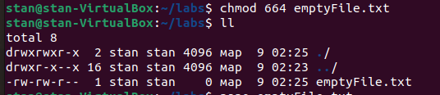

We are reverting back the permissions as they were.

20.change the ownership of the file to another user.

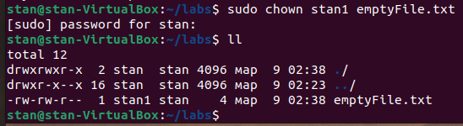

To change the ownership of a file to another user, we need to use “chown” command
“sudo chown newowner filename”, where newowner is the new owner of the file, and filename is the file that we wanna change the ownership to.

21.Create a group called group1 and assign who users to the group.

As we did it the last time, we create a group, and add users to it with flags -a and -G.

22. Create a file called group1.txt and redirect below input into the file: “This is our group file”.


As it shows we created a txt file, used a text editor to edit it and then cat the content.

23.Change the group of the file to one of your users.
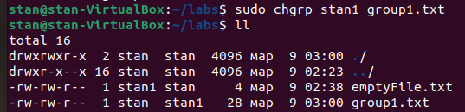

In order to change the group to one of the users, we can use “sudo chgrp username file.txt”, where the username is the user, and file.txt is the file.

24.Give members of the group group1 read/write access to this file.

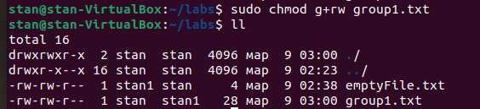

In order to give members of the group1 read/write access to the file, we need to type “sudo chmod g+rw group.txt”, so +g+rw” option is used to grant read/write access to the group owner of the file.

